 | 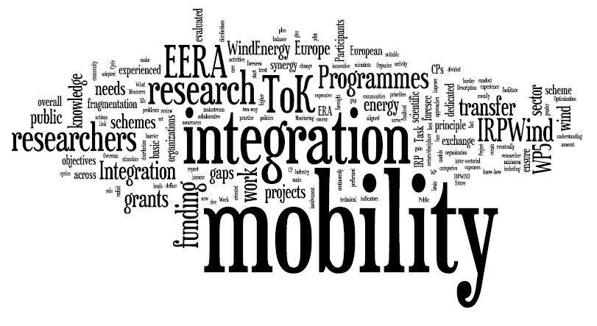 | 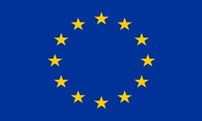
 |  | Funded by EU

Application form for Mobility grants within IRPWIND

***NOTE***
- All documents must be named as follows:
Sub Programme letter, Scheme no., Surname, Document type. Ex: A_01_Smidt_cv
For “Offshore Wind Energy”, Scheme 01 “2-4” weeks. See Table C) below.

- The application must be max. 6 pages, ex tables, figures and references.

- Applicant details
Applicant Name
Applicant Surname
Home Organization
EERA/IRP Partner? (yes/no)
Home Organization Postal address
E-mail
- Host Organization details
Institute name
EERA/IRP PARTNER?
Contact person
Country
E-mail

- Relevant Programme and length scheme
CORE PROJECT?  YES/NO  (Please erase the non-relevant) | (A) Offshore Wind Energy  (B) Grid Integration  (C) Structures and Materials | RELEVANT EERA SUB-PROGRAMME  Max 2  (Please erase the non-relevant) | (A) Offshore Wind Energy  (B) Grid Integration  (C) Structures and Materials  (D) Wind Conditions  (E) Aerodynamics  (F) Research Infrastructures  (G)Wind integration – economic and social aspects
Length of the grant scheme  (Please erase the non-relevant length) | Scheme:  (01) 2-4 weeks  (02) 4-26 weeks | Number of weeks:  Start date:

D. Project description
The application should take into account the following structure. Further sub-heading might be added.

TITLE OF THE PROJECT
1. Introduction
- Research topics, originality
- Technological Readiness Level (TRL) of the proposed concept.
- Definition of Key Performance Indicators (KPIs).
- Description of links to relevant EERA Sub Programmes (SP) and/or IRPWIND Core Projects (CP).

2. Description of national projects aligned to the proposed activities in both the sending and the receiving Organization
Please consider that at least one of the partners should have a national project relevant to the proposal.
- Description of national projects from the receiving Organization (please erase if not actual).
- Description of national projects from the sending Organization (please erase if not actual).
- Foreseen European added value of national alignment.
- Description of the host institute: e.g. infrastructure, experience etc.

3. Work plan
- Deliverables, milestones etc.

4. Benefits to EERA objective advancement
- Contribution to the advancement of the EERA strategy goals, gaps addressed.

5. Dissemination and Transfer of Knowledge to other IRP and EERA Wind participants
- Explain ToK or dissemination strategies and plan of future collaboration with other IRP/EERA partners.

6. Expected results
- Methodologies and/or databases and/or best practices functional to the activities of the IRP and EERA strategic agenda objectives.
- Assessment of the advancement of the TRL.
- Assessment of the KPIs.

